DATA DEFINITION LANGUAGE

AIM:
- Create the database;
- Select the currrent database
- Create the following tables
- Students(sid,sname,sex,dob,dno)
- Department(dno,dname)
- Faculty(F,id,fname,designation,salary,dno)
- Course(cid,cname,credits,dno)
- Register(sid,cid,sem)
- Teaching(f_id,cid,sem)
- Hostel(hid,hname,seats)
- Include the necessary constraints NOT NULL,DEFAULT,CHECK and PRIMARY KEY,UNIQUE
- Create a database college
- Use college as the current database
- Display all the tables in college database

- Display all the tables in college database
- Describe the structures of all tables
- Modify the student table to add a new field ‘grade’

OBJECTIVES
To understand DDL commands
THEORY
It is very important to understand the database before learning MySQL. A database is an application that stores the organized collection of records. It can be accessed and manage by the user very easily. It allows us to organize data into tables, rows, columns, and indexes to find the relevant information very quickly. Each database contains distinct API for performing database operations such as creating, managing, accessing, and searching the data it stores. Today, many databases available like MySQL, Sybase, Oracle, MongoDB, PostgreSQL, SQL Server, etc. In this section, we are going to focus on MySQL mainly.

What is MySQL?
MySQL is currently the most popular database management system software used for managing the relational database. It is open-source database software, which is supported by Oracle Company. It is fast, scalable, and easy to use database management system in comparison with Microsoft SQL Server and Oracle Database. It is commonly used in conjunction with PHP scripts for creating powerful and dynamic server-side or web-based enterprise applications.
It is developed, marketed, and supported by MySQL AB, a Swedish company, and written in C programming language and C++ programming language. The official pronunciation of MySQL is not the My Sequel; it is My Ess Que Ell. However, you can pronounce it in your way. Many small and big companies use MySQL. MySQL supports many Operating Systems like Windows, Linux, MacOS, etc. with C, C++, and Java languages.
MySQL is a Relational Database Management System (RDBMS) software that provides many things, which are as follows:
- It allows us to implement database operations on tables, rows, columns, and indexes.
- It defines the database relationship in the form of tables (collection of rows and columns), also known as relations.
- It provides the Referential Integrity between rows or columns of various tables.
- It allows us to updates the table indexes automatically.
- It uses many SQL queries and combines useful information from multiple tables for the end-users.

DATABASE QUERIES
- Create database
We can create a new database in MySQL by using the CREATE DATABASE statement
CREATE DATABASE [IF NOT EXISTS] database_name
- Select database
SELECT Database is used in MySQL to select a particular database to work with
USE database_name
- Drop database
We can drop an existing database in MySQL by using the DROP DATABASE statement
DROP DATABASE [IF EXISTS] database_name;

TABLE QUERIES
- Create table
CREATE TABLE [IF NOT EXISTS] table_name
- Alter table
ALTER TABLE table_name
- Rename table
RENAME TABLE old_tab1 TO new_tab1,
- Truncate table
TRUNCATE [TABLE] table_name;
- Describe table
{DESCRIBE | DESC} table_name
- Drop table
DROP [ TEMPORARY]TABLE [IF EXISTS ] table_name [RESTRICT | CASCAD
- Temporary table
CREATE TEMPORARY TABLE table_name(
- Copy table
CREATE TABLE new_table_name
SELECT column1, column2, column3
FROM existing_table_name;
- Repair table
REPAIR TABLE name;
- Add/Delete columns
- ALTER TABLE table_name
- ADD COLUMN column_name column_definition [FIRST|AFTER existing_column ];
- Show colums
SHOW COLUMNS FROM column name;
- Rename colums
- ALTER TABLE balance
- CHANGE COLUMN (current column name)(to column name) VARCHAR(25);

CONSTRAINTS
- NOT NULL:The NOT NULL constraint enforces a column to NOT accept NULL values.
- PRIMARY KEY:The PRIMARY KEY constraint uniquely identifies each record in a table.
Primary keys must contain UNIQUE values, and cannot contain NULL values.
- FOREIGN KEY:A FOREIGN KEY is a field (or collection of fields) in one table, that refers to the PRIMARY KEY in another table.
- CHECK:The CHECK constraint is used to limit the value range that can be placed in a column.
- DEFAULT:The DEFAULT constraint is used to set a default value for a column.
The default value will be added to all new records, if no other value is specified
- UNIQUE:The UNIQUE constraint ensures that all values in a column are different.

PROCEDURE

RESULTS:
DDL commands have been executed

OUTPUT
Creating table student and inserting values:
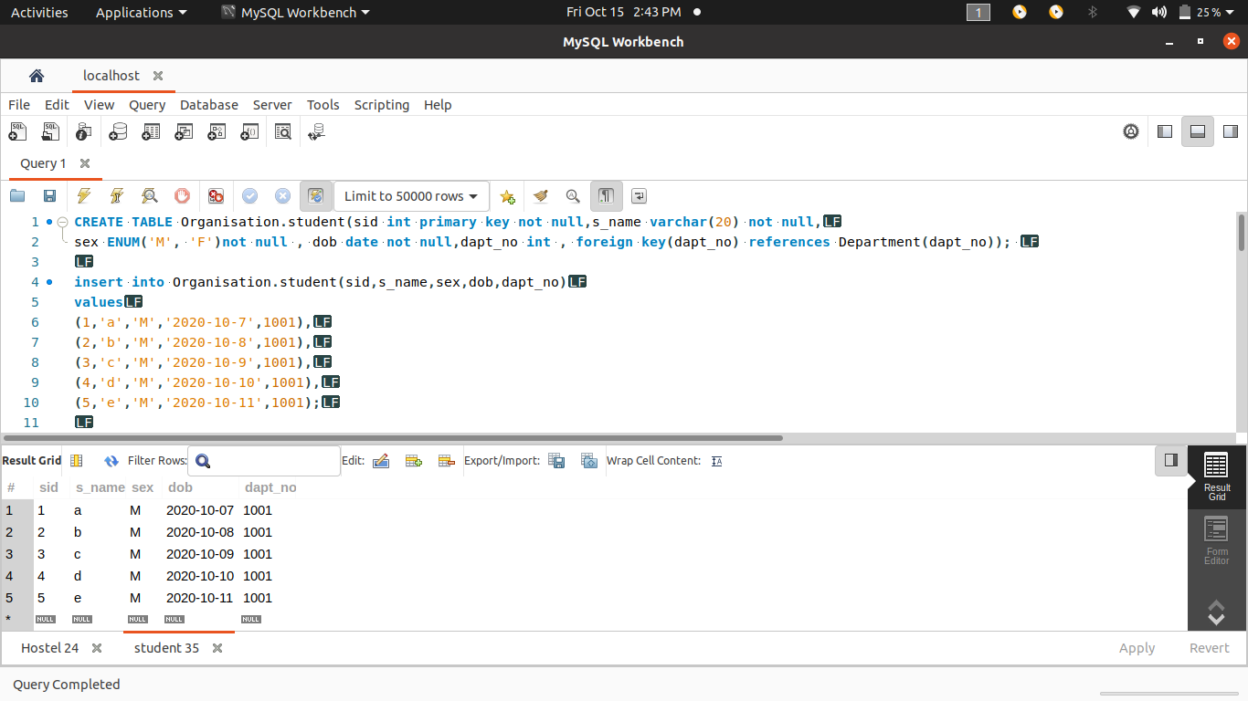

Creating table Department and inserting values:
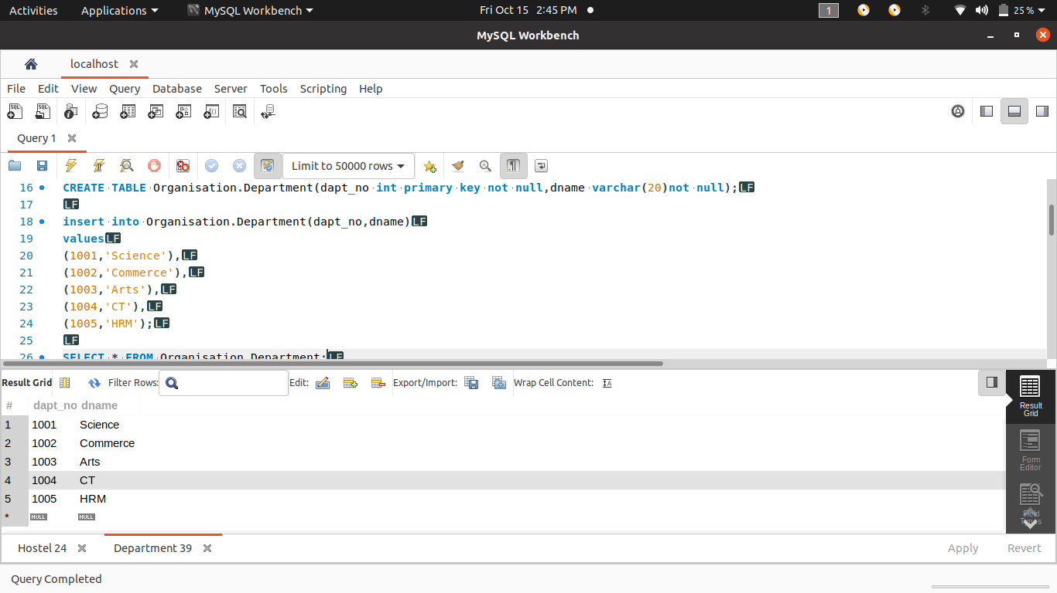
Creating table Faculty and inserting values:
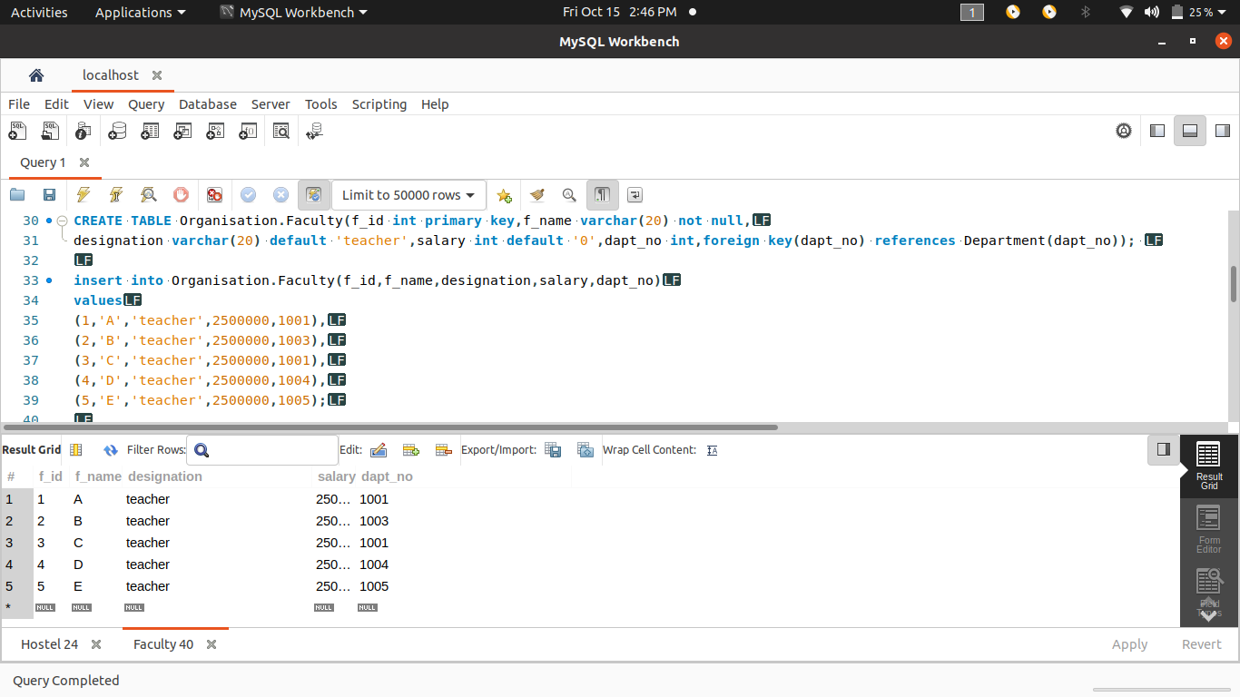

Creating table Course and inserting values:
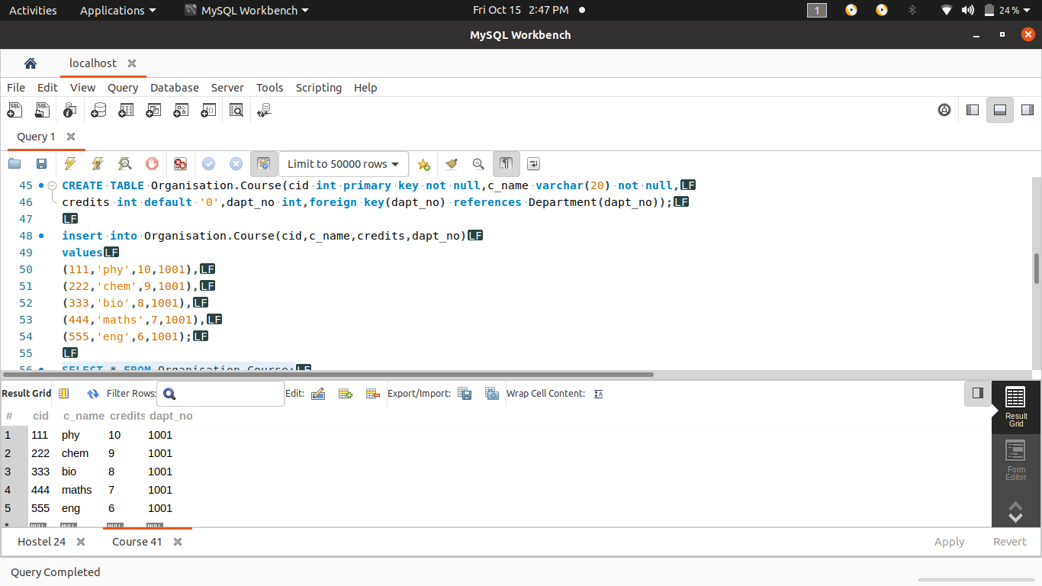
Creating table Register and inserting values:
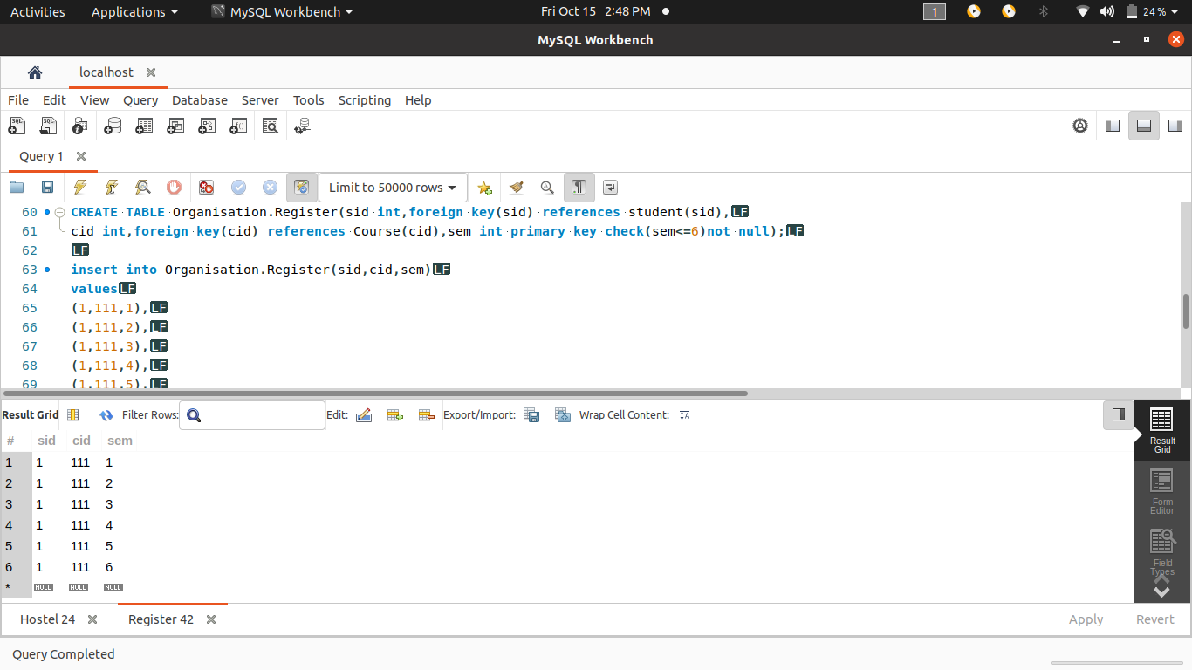

Creating table Teaching and inserting values:
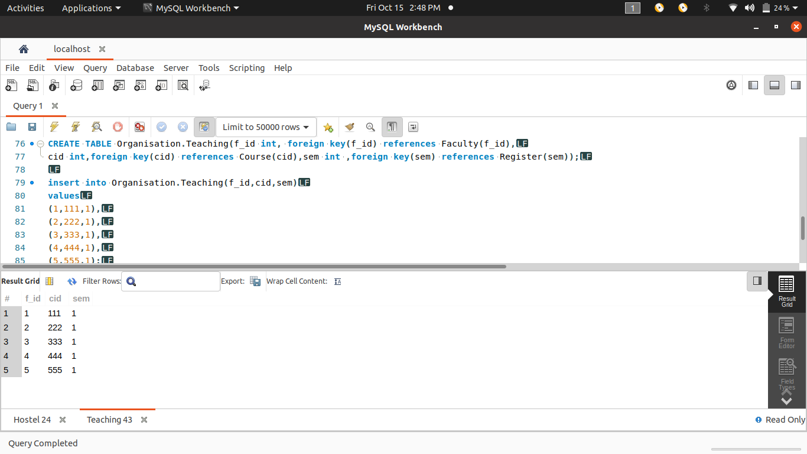
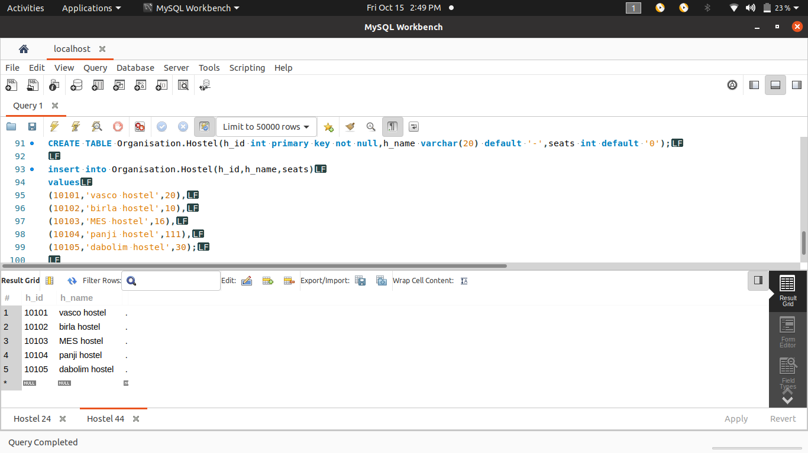
Creating table Hostel and inserting values:

2)Included all the necessary constraints

3)Created database college
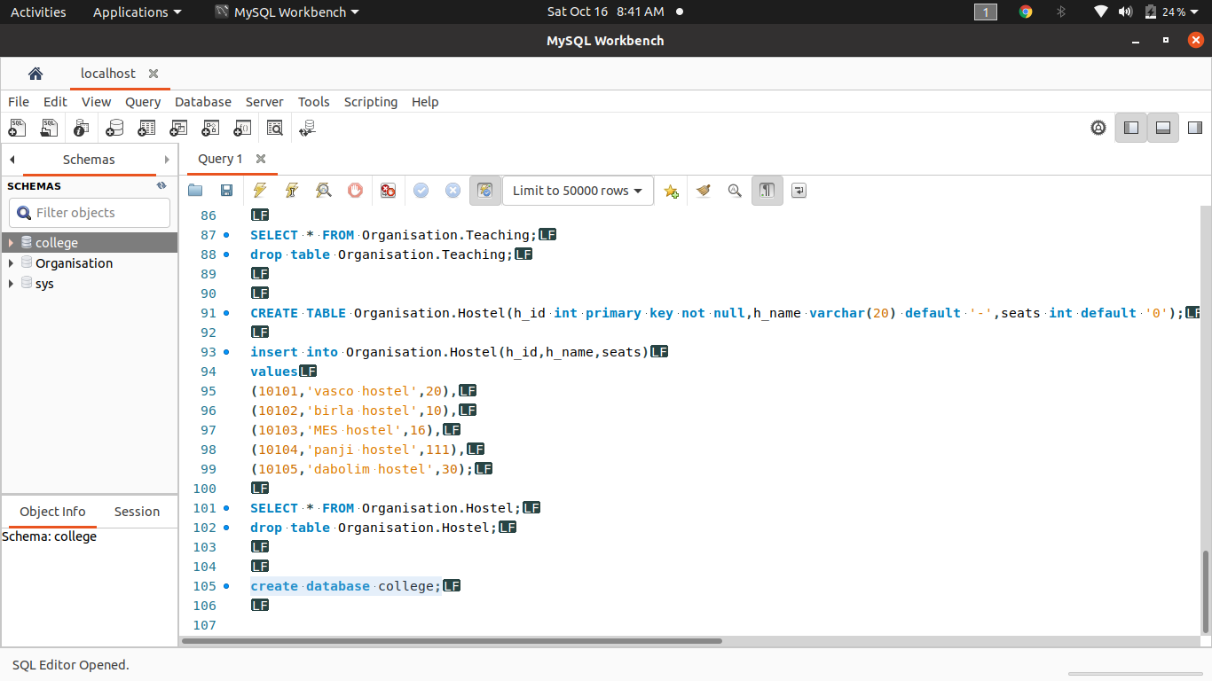
4) used college as current database
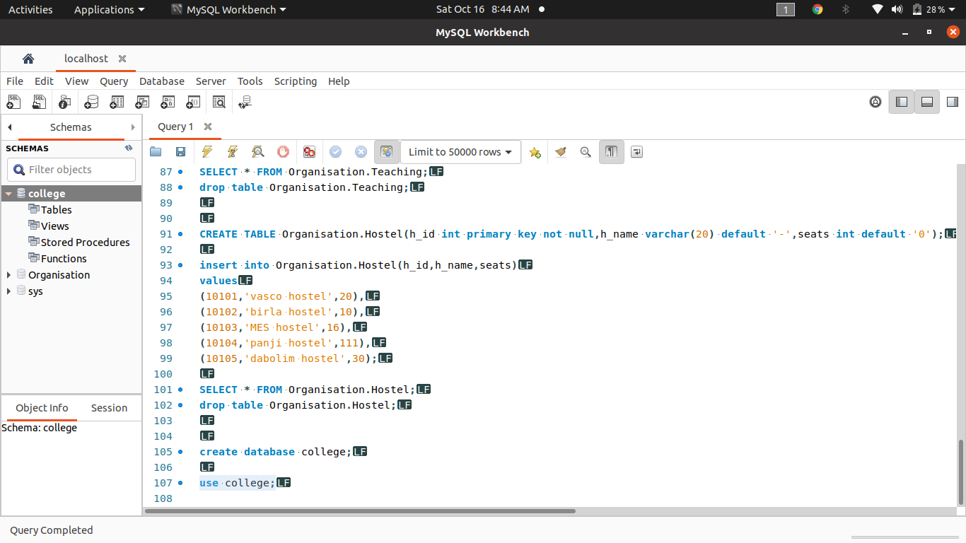

5)Dispplay all the tables in college database
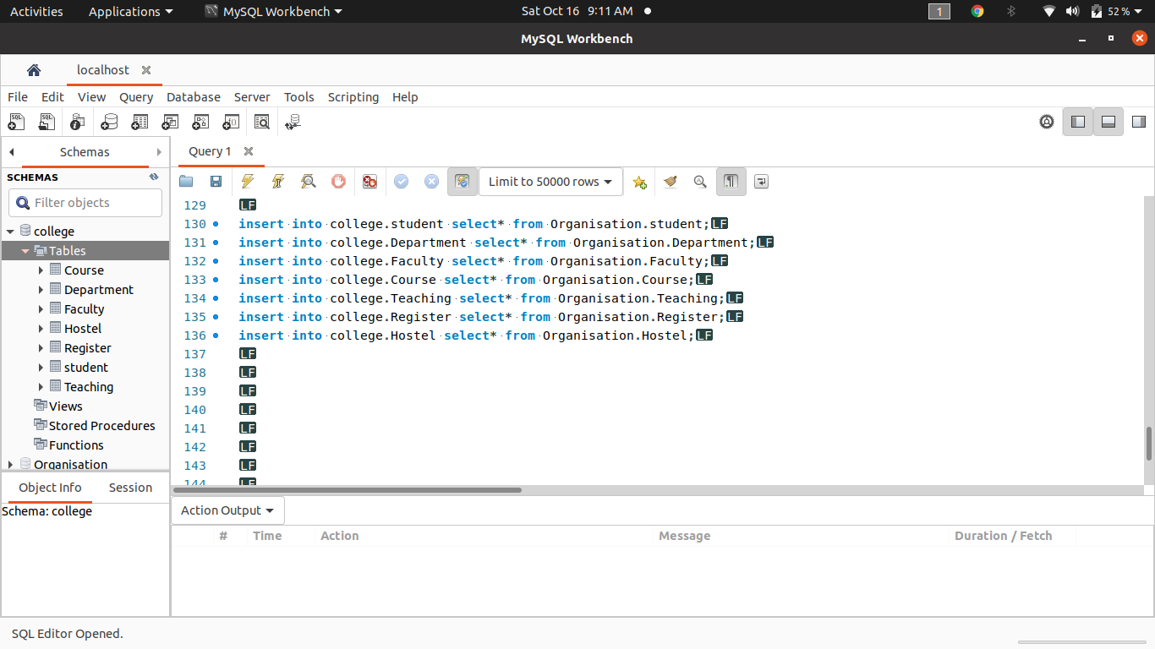
6)Describe the structure of all tables
STUDENT

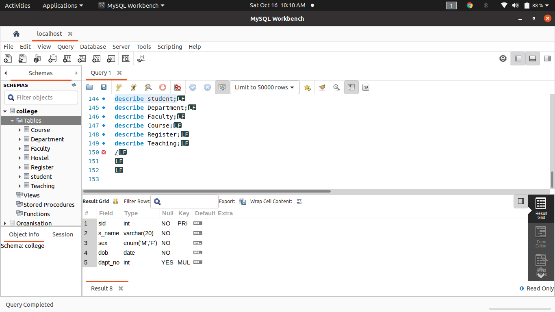
DEPARTMENT
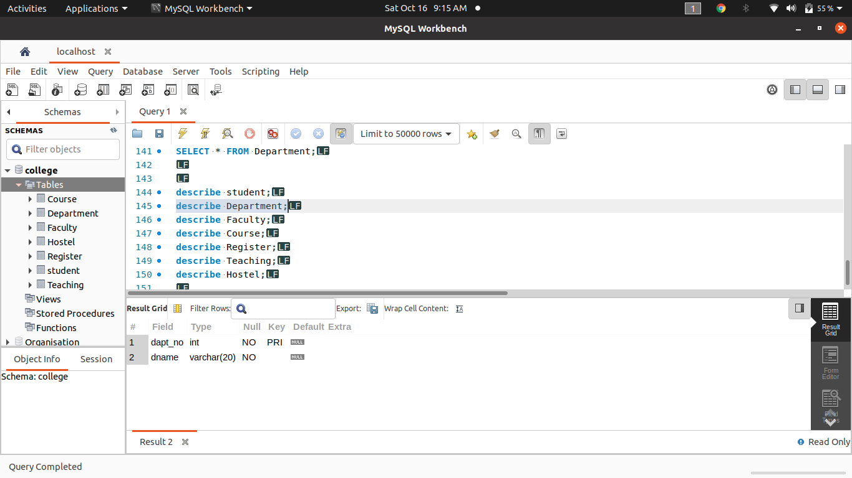
FACULTY
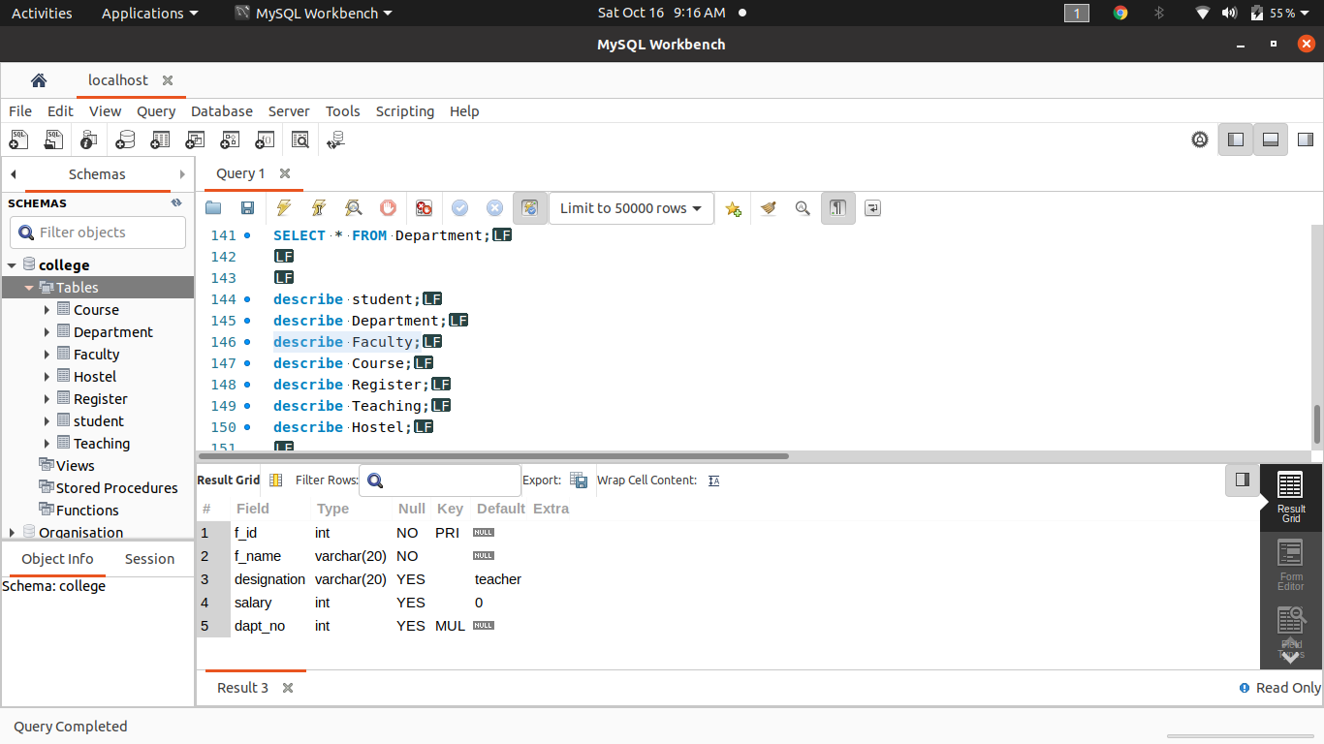
COURSE
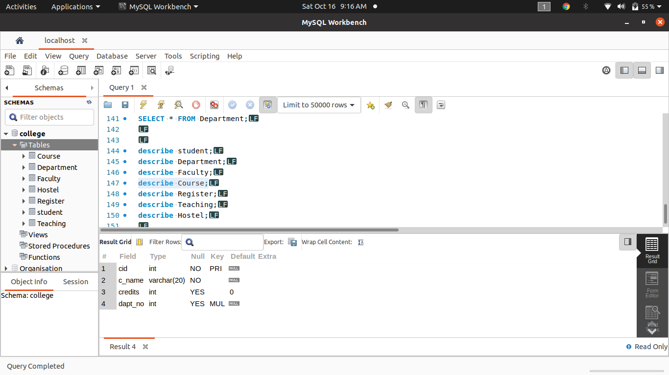
REGISTER
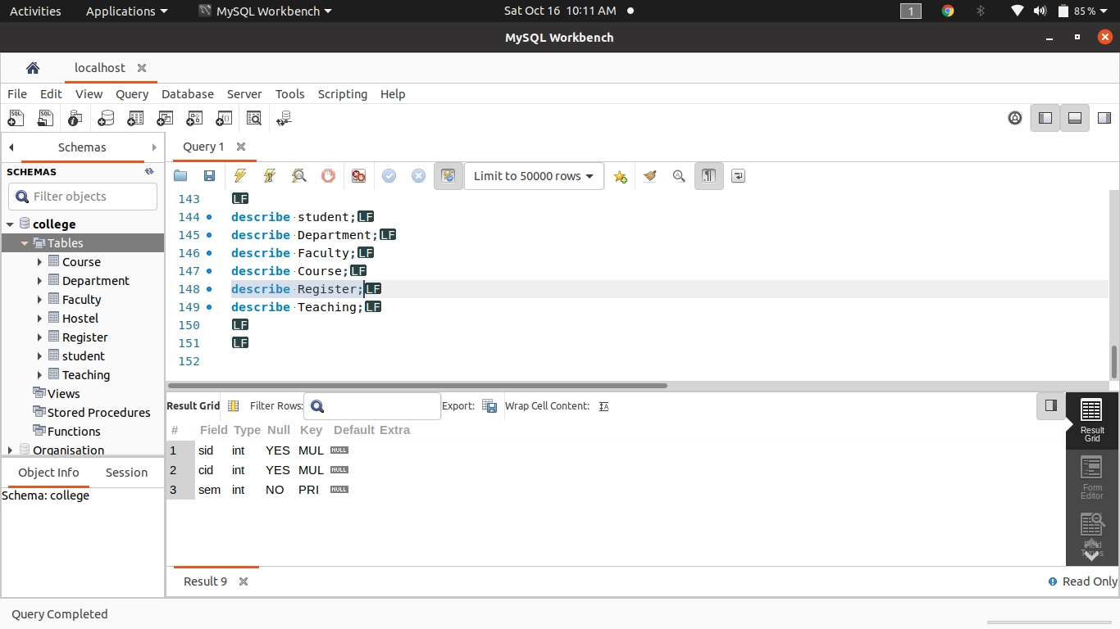
TEACHNG
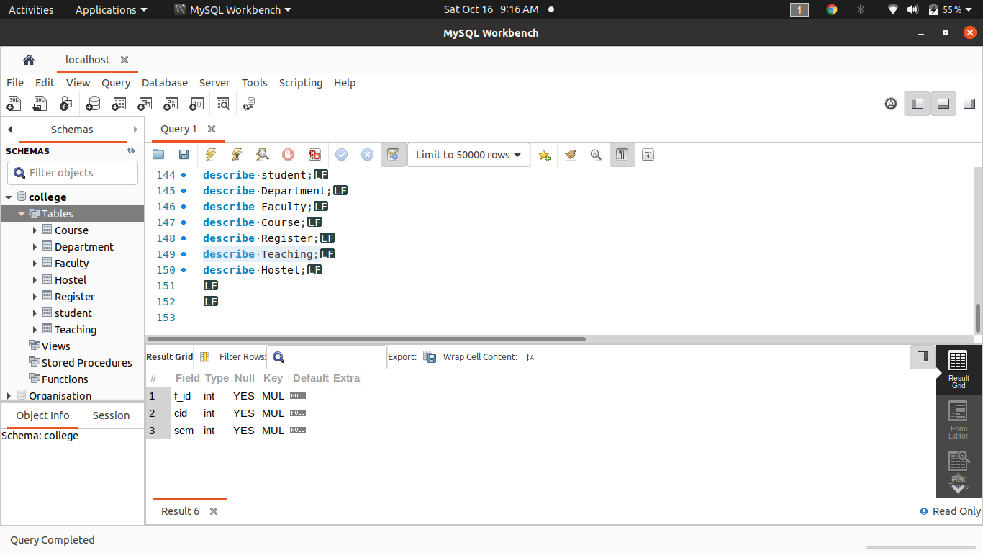
HOSTEL
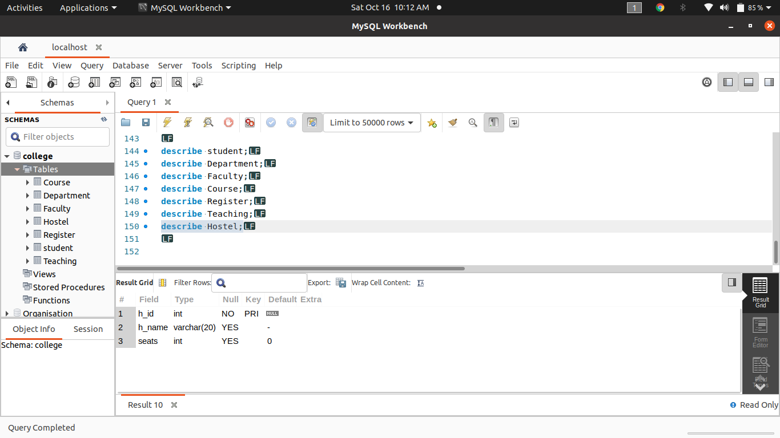

7)Modify the student table to add a new field ‘grade’
